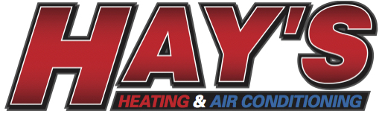
Service Agreements

1 System - $159.00* 3 Systems - $279.00*
2 Systems - $219.00* 4 Systems - $339.00*
*plus tax
Includes 2 Cleanings - one Cooling and one Heating service

Service Agreements Include:


Cooling Inspection

*Check/calibrate thermostat as required
*Inspection of air filtration system
*Inspect any condensate drain pans for proper operation
*Inspect unit wiring & electrical disconnect
*Visually inspect/test capacitors for leakage & rust (Indoor unit)
*Inspect blower motor
*Complete operations sequence check
*Check evaporator for adequate airflow
*Inspect & flush condensate lines & check condensate pump operation (if so equipped)
*Inspect cooling system for unusual vibration or loose parts
*Check refrigerant level
*Inspect contactor for pits & burns
*Tighten screw lug terminals in condensing unit
*Check condenser motor bearings/lubricate unsealed condenser motor bearings (as necessary)
*Inspect fan blade for cracks or defects
*Inspect & clean outdoor unit, including washing coils


Heating Inspection

*Inspect flue & venting for obstructions/leaks
*Inspect entire furnace for loose or worn parts and abnormal vibrations
*Check temperature rise across heat exchanger for over heating
*Check & adjust manifold gas pressures (if applicable)
*Inspect furnace wiring assembly for loose connections
*Inspect gas burners (if applicable)
*Inspect burner ignition system & assembly
*Check high limit control (adjust as needed)
*Inspect gas lines & connections at furnace for leaks (if applicable)
*Inspect heat exchanger for sooting, corrosion, cracks & deformities
*Check electrical circuit to furnace & test all electrical controls
*Inspect gas valve for corrosion, leaks, restriction of gas flow & abnormal noise
*Test & adjust the unit for peak operating efficiency
*Check defrost cycle & reversing valve operation (heat pumps only)
*Tighten screw lug terminals in condensing unit (heat pumps only)
*Check refrigerant level (heat pumps only)
*Check emergency heat systems for proper operation (heat pumps only)

Hays Heating & Air Conditioning - Office (919) 471-8020
P.O. Box 61548, Durham, NC 27715 Email – hayshvac@gmail.com Website: hayshvac.net

